 | B.M.S. COLLEGE OF ENGINEERING, BANGALORE-19  Computer Science & Engineering
INTERNALS-1I
Course Code: 23CS4PCADA |  | Course Title: Analysis and Design of Algorithms
Semester: 4 |  | Maximum Marks: 40 | Date: 25-04-2025
Faculty Handling the Course: |  | Dr. JSN, Dr. KPM, SDV, NM, Dr. SG, VBM
Instructions: Internal choice provided in Part C.

PART-A
Total 5 Marks (No Choice)
No. | Question | Marks | CO-PO
1 | Analyse the different variations of Decrease and conquer technique with respect to time complexity. | 5 | 1-2

PART-B
Total 15 Marks (No Choice)

No. | Question | Marks | CO-PO
2 a) | You are working on a large software project that consists of multiple modules. Each module may depend on one or more other modules. Before building a module, all its dependencies must be built first. As a software developer, you are tasked with designing an algorithm to determine the correct order of modules so that all dependencies are respected. There are 7 modules A,B,C,D,E,F,G. The dependencies are as given below. Draw the DAG for the given modules .Use appropriate technique to determine the correct order starting from module D.  Module A is Prerequisite for module B and C  Module B is prerequisite for E and G  Module C should be completed before F  Module D is prerequisite for A,B,C,F,G  Module G should be completed before F and E | 5 | 2-1
2 b) | You are working as a software developer for a fintech startup. Your team is building a digital wallet app that needs to handle change-making operations efficiently. The app must determine the minimum number of coins required to make up a specific amount using a given set of denominations. Apply a suitable method and solve the Problem for the denominations ={1,3,4} which should add up to n=6. | 5 | 2-2
2 c) | Consider the data shown below Obtain the best set of combinations for assigning Jobs to three persons by applying suitable Brute force Technique.  J1 J2 J3  P1 5 3 2  P2 8 7 5  P3 4 9 12 | 5 | 2-2

PART- C
Total 20 Marks

No. | Question | Marks | CO-PO
3 a) | A delivery company is preparing to load packages into a truck that can carry a maximum of 7 kg. There are 5 packages available, and each has a weight and a value (representing the delivery fee the company earns from delivering it). Design the algorithm where the company can only take full packages (no splitting). Identify the combination of packages should the company load to maximize the total delivery fee without exceeding the truck's weight capacity. Find the maximum total value the company can earn, and the combinations of packages that should be selected.  Package Weight(Kg) Value($)  1 2 100  2 3 120  3 6 90  4 1 70  5 4 50 | 10 | 2-2
 | OR
3 b) | i)Assume that there are 4 objects with the object numbers 3, 5, 8 and 9 in a retail shop. A customer wishes to purchase all the above objects. Show all the possible orders in which these objects can be purchased by the customer using most efficient technique.  ii) You are developing a routing module for a logistics company’s delivery management system. The company operates in multiple cities, and goods often need to be transported through a series of intermediate cities to reach the final destination at minimal cost. To optimize delivery planning, apply appropriate algorithmic technique to determine the shortest paths between all pairs of cities, considering the direct and indirect routes available. Show the steps in detail.  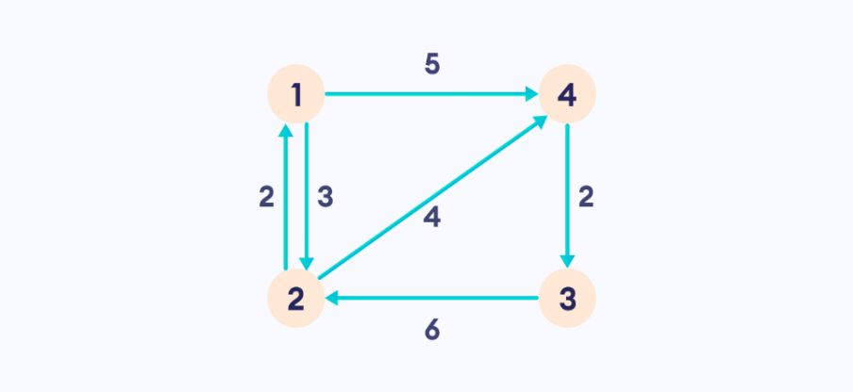 | 5+5 | 2-2
4a) | You are a logistics manager at a warehouse hub located at Node 1. Your goal is to deliver goods to all other distribution centers represented by Nodes 2 through 5. The edges between nodes represent the available roads, and the weights are the travel times in minutes between the centers.  Your objective is to determine the fastest delivery paths from Node 1 to all other centres to minimize travel time and fuel costs by considering the below graph. Show the steps in detail by applying appropriate algorithm and mention the time complexity.  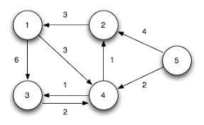 | 10 | 2-2
 | OR
4b) | You are a data compression engineer at a tech company. Your team is developing a file compression tool, and you're responsible for implementing the Huffman encoding module. Your task is to analyze character frequencies in a sample text and build a Huffman tree to generate optimal prefix codes for each character. Also encode ABCDAD and Decode 10011011011101 using Huffman tree.  Character A B C D -  Frequency 0.35 0.1 0.2 0.2 0.15 | 10 | 2-2

***ALL THE BEST***

